Data Mining Project
Table of Contents
Executive Summary 2
Business Understanding 2
Data Understanding 3
Data Preparation 4
Modeling & Results 7
Question 1: Factors Influencing BMI (Linear Regression) 7
Question 2: Factors Influencing Obesity (Decision Tree) 9
Question 3: Profiles of Six Obesity Levels 12
Question 4: Lifestyle Clusters (K-Means) 13
Conclusion 17
References 18

Table of Figures
Figure 1: CRISP-DM methodology 3
Figure 2: Dataset Statistical Summary 4
Figure 3: BMI Categories attribute generation 5
Figure 4: EFBM and FIZZY numeric conversion 6
Figure 5: Age 20+ Filter applied 6
Figure 6: Process Diagram of Q1 7
Figure 7: Linear regression Results 8
Figure 8: Process Diagram of Q2 10
Figure 9: Confusion Matrix Analysis & Graph 11
Figure 10: Most Important Predictors (from Decision Tree) 11
Figure 11: Key Decision Tree Insights 11
Figure 12: Process Diagram of Q3 12
Figure 13: Six Profiles Comparison Table 13
Figure 14: Key Insights from Profiles 13
Figure 15: Process Diagram of Q4 14
Figure 16: Centroid Table (Z-Score normalized values) 15
Figure 17: Performance vector 15

Predicting and Understanding Obesity: A Data Mining Approach

Executive Summary
This project analyzed lifestyle and health factors influencing Body Mass Index (BMI) and obesity using a dataset of 2,111 individuals. Key findings reveal that eating between meals (EFBM) and history of being overweight (HoV) are the strongest predictors of obesity. Cluster analysis identified four distinct lifestyle groups, with only 17% exhibiting consistently healthy patterns. Recommendations focus on promoting physical activity, reducing fizzy drink consumption, and encouraging active transportation.

Business Understanding
Problem Statement
Obesity is a growing health crisis. This project aims to identify factors influencing BMI and obesity to support targeted interventions.
Project Objectives
- Identify factors influencing BMI
- Determine factors influencing obesity classification
- Profile individuals across six obesity levels
- Categorize individuals by lifestyle and health habits
CRISP-DM Framework
This analysis follows the CRISP-DM methodology:

Figure 1: CRISP-DM methodology

Data Understanding
Dataset Description
The dataset contains 2,111 records with 17 attributes:
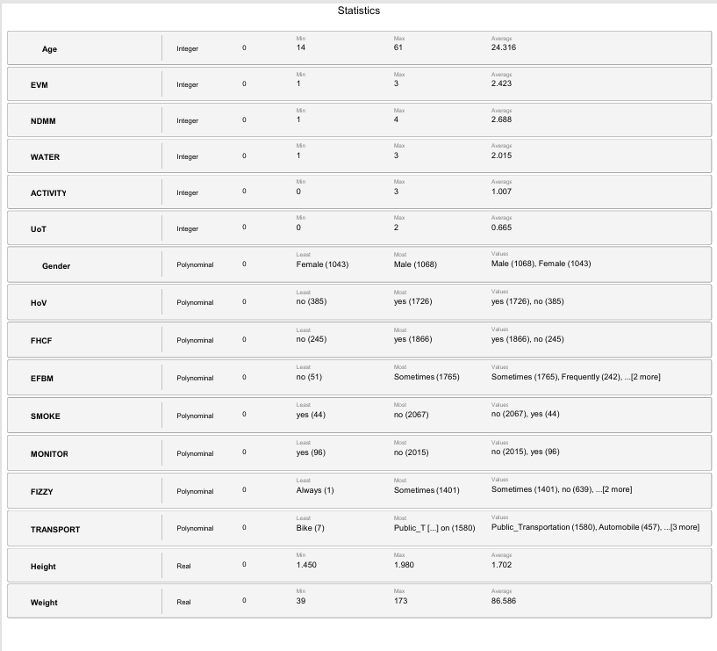
Figure 2: Dataset Statistical Summary

Data Preparation
BMI Calculation
BMI was calculated using:
$$BMI = Weight / (Height × Height)$$
BMI Categories (6 Classes)
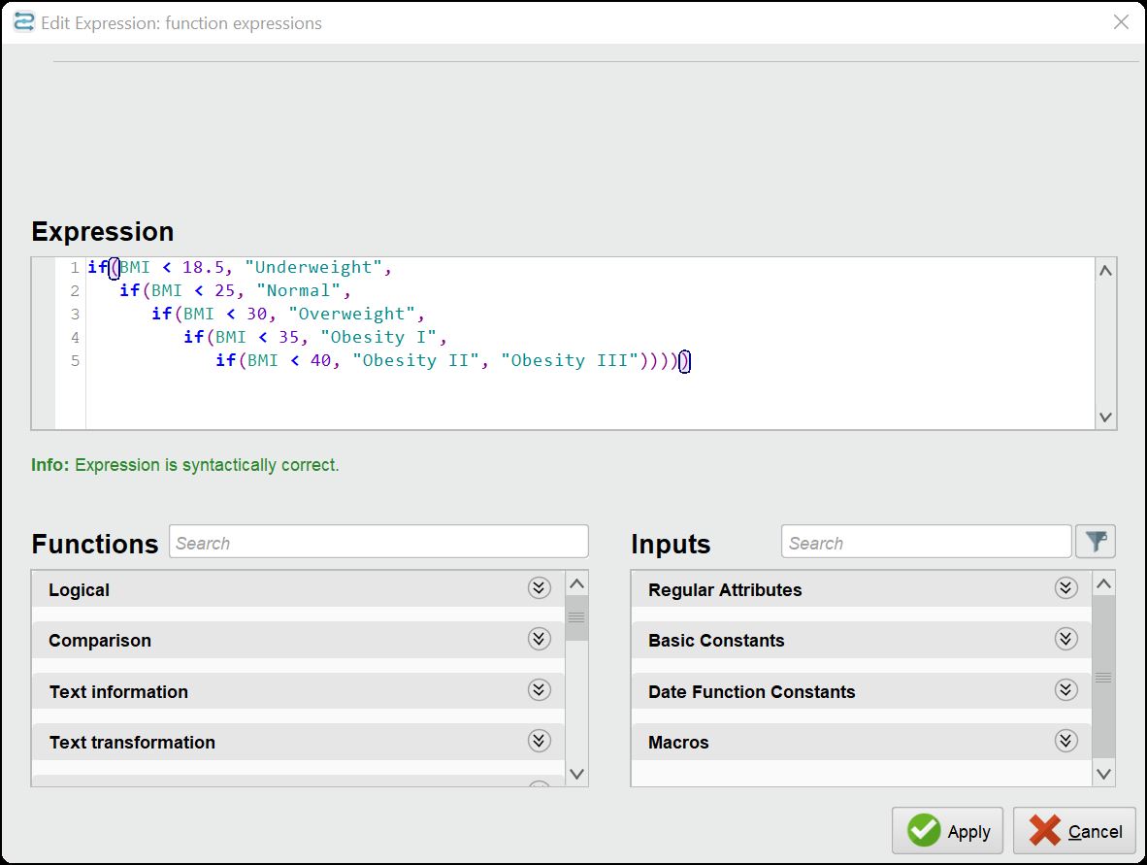
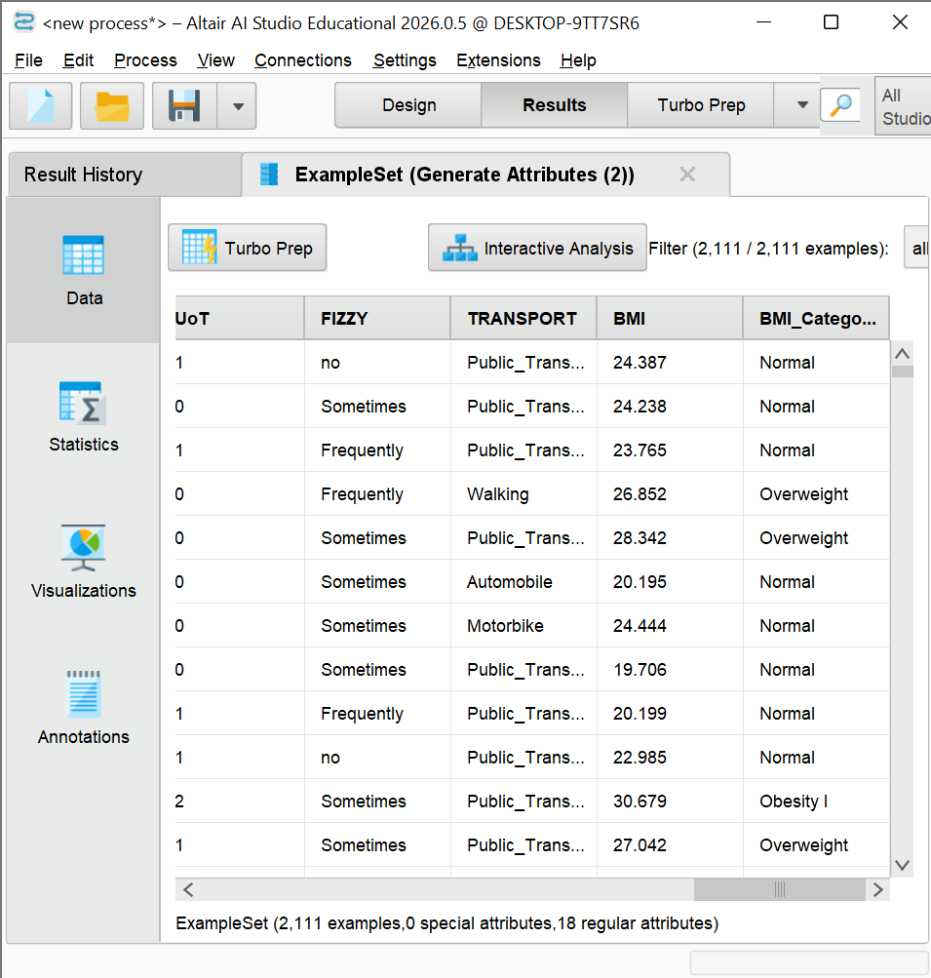
Figure 3: BMI Categories attribute generation
Ordinal Variable Conversion
EFBM and FIZZY were converted to numeric (1-4):
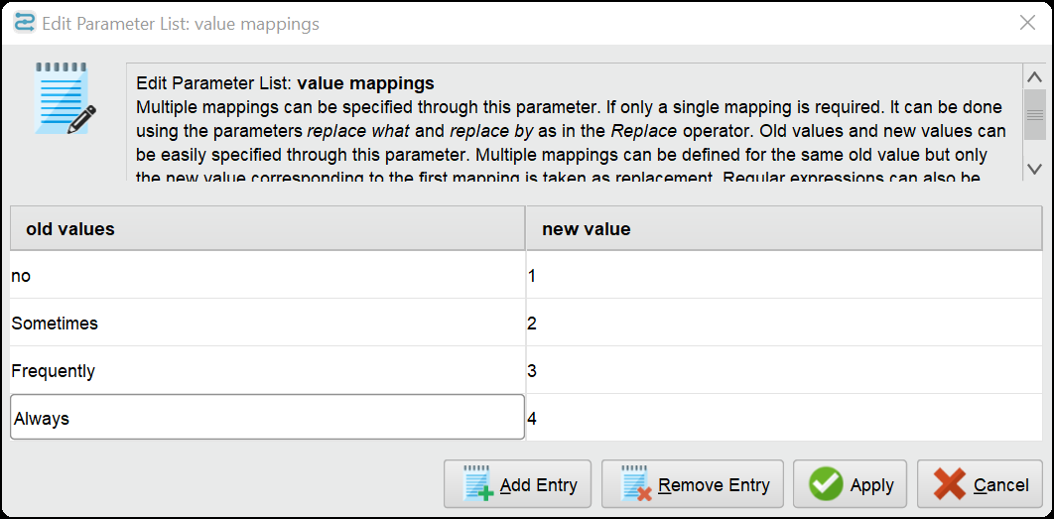
Figure 4: EFBM and FIZZY numeric conversion
Binary Variable Conversion
All Yes/No variables converted to 1/0 for regression modeling.
dult Filtering
Only adults aged 20+ were included: 1,639 records (removed 472 individuals under 20).
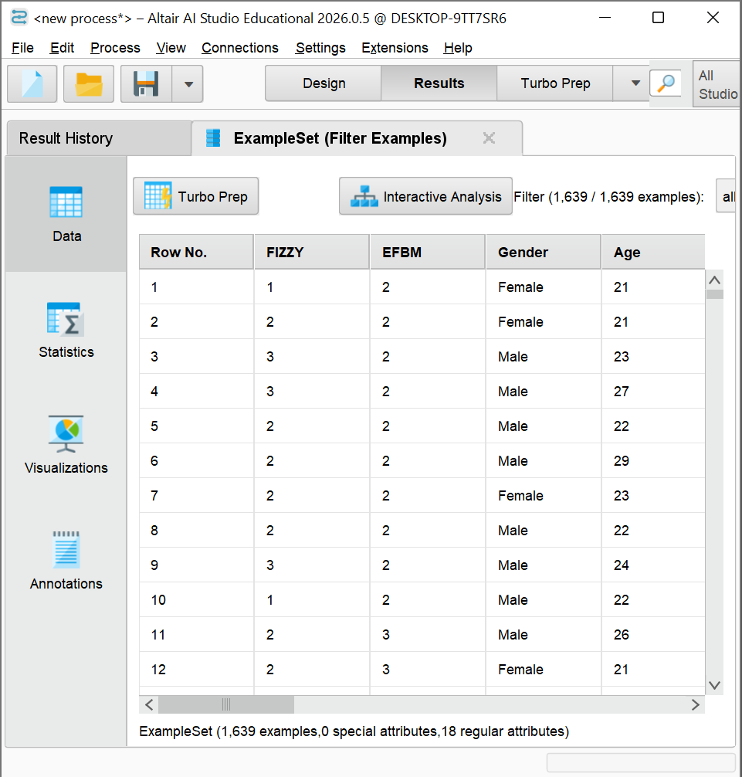
Figure 5: Age 20+ Filter applied

Modeling & Results

Question 1: Factors Influencing BMI (Linear Regression)
Business Understanding
Goal: Identify which lifestyle factors significantly affect continuous BMI values to understand what increases or decreases BMI.
Data Understanding
Target variable: BMI (continuous). Predictor variables: all lifestyle factors including EFBM, HoV, FHCF, Transport, FIZZY, and others.
Data Preparation
- BMI calculated from weight/height²
- Adults only (age ≥ 20 filter applied)
- Ordinal variables EFBM and FIZZY converted to numeric (1-4)
- Binary Yes/No variables converted to 1/0
Modeling
Linear regression with BMI as target variable and all lifestyle factors as predictors.
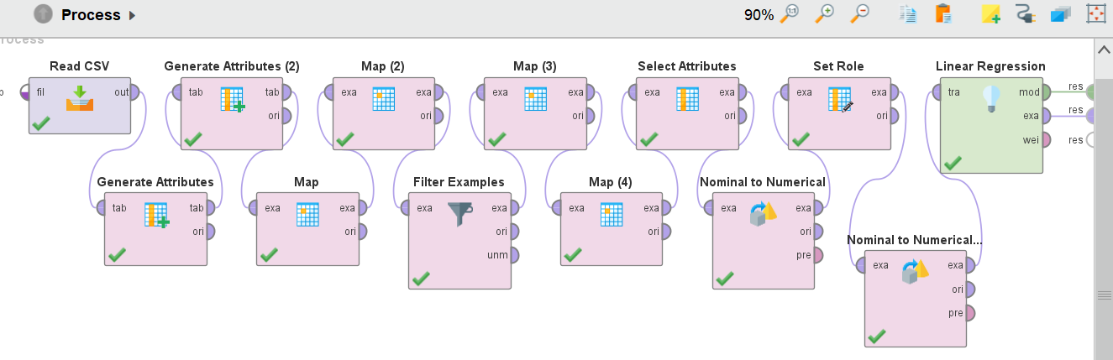
Figure 6: Process Diagram of Q1
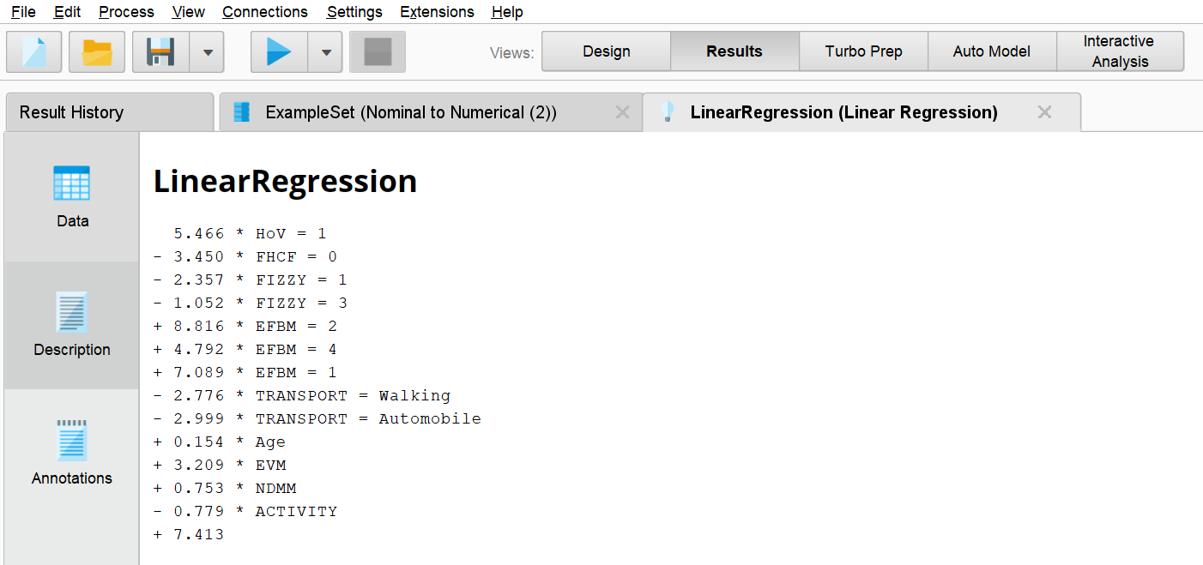
Figure 7: Linear regression Results
Evaluation
Factors INCREASING BMI
Factor | Coefficient | Interpretation
EFBM = Sometimes | +8.82 | Strongest positive effect
EFBM = No | +7.09 | Not eating between meals also increases BMI
HoV = Yes | +5.47 | History of overweight increases BMI
EFBM = Always | +4.79 | Always eating between meals increases BMI
Factors DECREASING BMI
Factor | Coefficient | Interpretation
FHCF = No | -3.45 | No high-caloric food = lower BMI
Transport = Automobile | -3.00 | Car use associated with lower BMI
Transport = Walking | -2.78 | Walking decreases BMI
FIZZY = No | -1.05 | No fizzy drinks = lower BMI
Conclusion for Q1
Eating habits (EFBM), weight history (HoV), and transportation choices are the strongest determinants of BMI.

Question 2: Factors Influencing Obesity (Decision Tree)
Business Understanding
Goal: Predict categorical obesity level (not continuous BMI) and rank predictor importance to identify key factors influencing obesity classification.
Data Understanding
Target variable: BMI Categories (6 classes: Underweight, Normal, Overweight, Obesity I, Obesity II, Obesity III). Predictor variables: same lifestyle factors as Q1.
Data Preparation
Same data preparation as Q1, with additional attention to class balance addressed through cross-validation.
Modeling
Decision tree classifier with 6-fold cross validation to predict BMI categories.
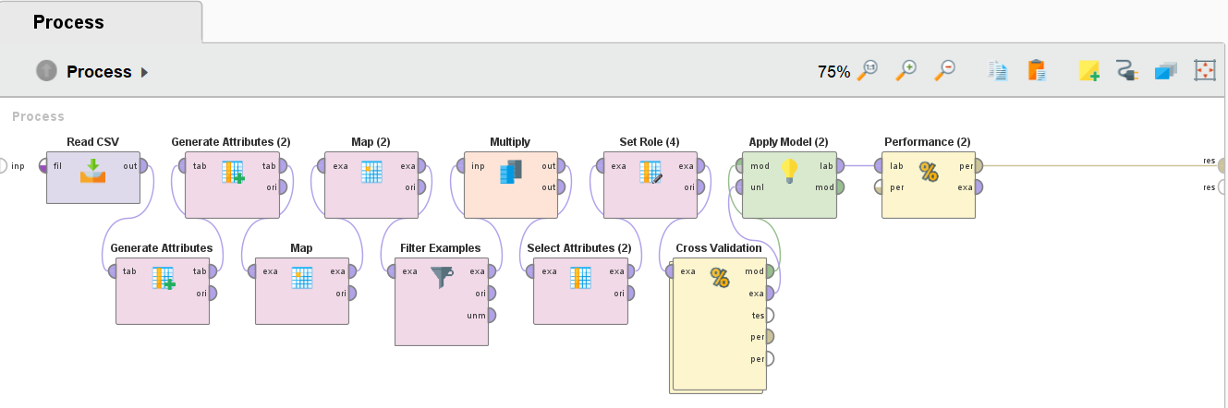
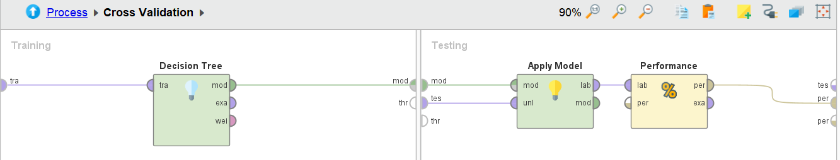
Figure 8: Process Diagram of Q2
Evaluation
- Overall Accuracy: 47.90%
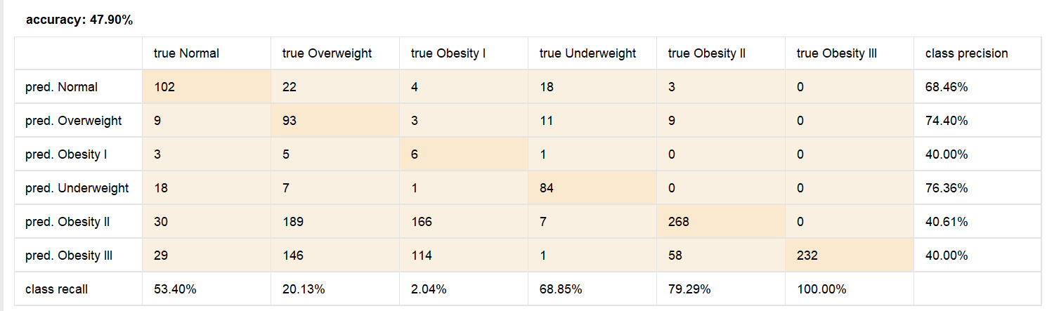
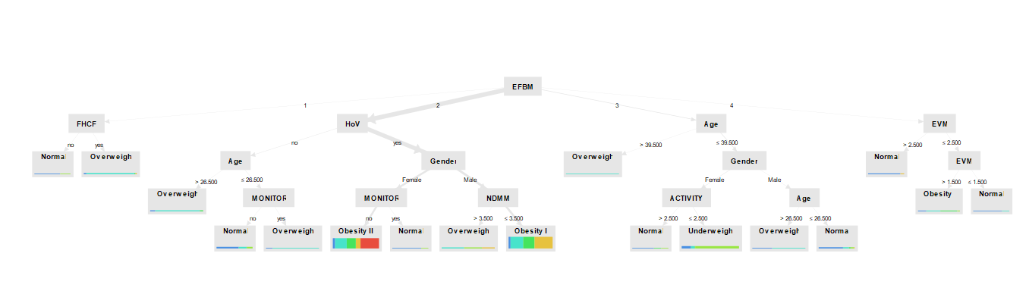
Figure 9: Confusion Matrix Analysis & Graph

Figure 10: Most Important Predictors (from Decision Tree)

Figure 11: Key Decision Tree Insights
Conclusion for Q2
Eating between meals is the single most important predictor of obesity status. History of overweight, gender, and calorie monitoring are also critical factors.

Question 3: Profiles of Six Obesity Levels
Business Understanding
Goal: Describe how lifestyle factors differ across each obesity class to understand the unique characteristics of individuals at each BMI level.
Data Understanding
Separate analysis by each of the six BMI categories: Underweight, Normal, Overweight, Obesity I, Obesity II, Obesity III.
Data Preparation
Filtered data by each BMI category and computed descriptive statistics for each group.
Modeling
Filtered data by each BMI category and computed descriptive statistics.
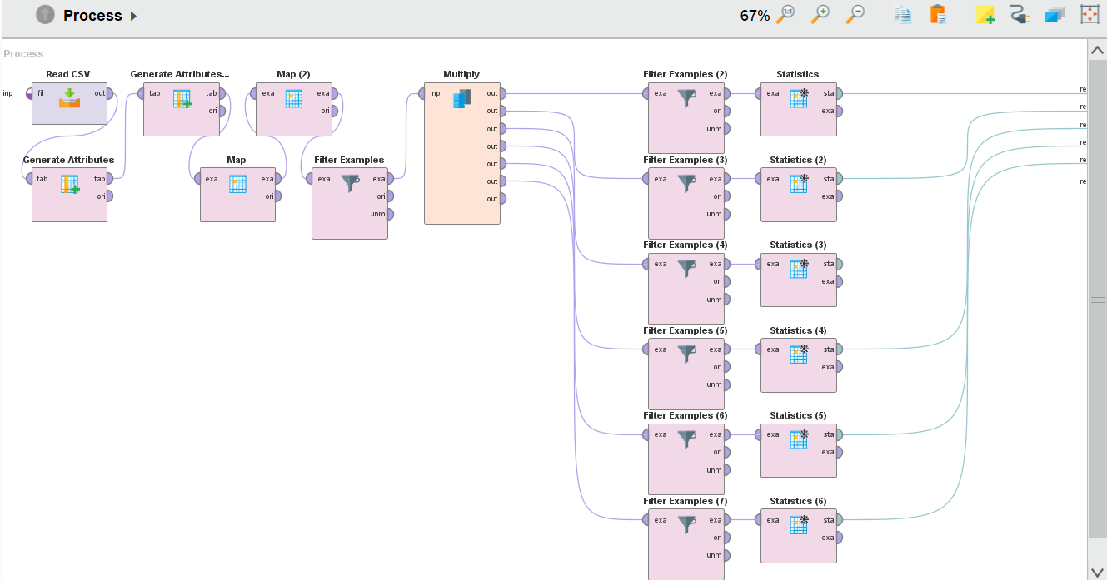
Figure 12: Process Diagram of Q3
Metric | Under-weight | Normal | Over-weight | Obesity I | Obesity II | Obesity III
Count | 122 | 191 | 462 | 294 | 338 | 232
% Male | 19.7% | 50.3% | 60.0% | 59.9% | 82.5% | 0%
Avg Age | 21.8 | 24.0 | 26.8 | 27.8 | 28.0 | 23.7
Avg ACTIVITY | 1.18 | 1.22 | 0.99 | 1.00 | 0.82 | 0.64
Avg WATER | 1.93 | 1.91 | 2.05 | 2.22 | 1.81 | 2.38
Avg UoT | 0.68 | 0.59 | 0.59 | 0.61 | 0.56 | 0.57
Avg EVM | 2.66 | 2.36 | 2.25 | 2.19 | 2.49 | 3.00
Avg BMI | 17.6 | 22.3 | 27.2 | 32.4 | 37.2 | 42.8
Figure 13: Six Profiles Comparison Table
Trend | Observation
Physical Activity | Decreases as obesity increases (1.18 → 0.64)
Male % | Increases from 20% to 83% (except Obesity III – all female in this sample)
Vegetable Consumption | Highest in Underweight (2.66) and Obesity III (3.00)
Water Intake | Highest in Obesity III (2.38)
Figure 14: Key Insights from Profiles
Conclusion for Q3
As obesity level increases, physical activity decreases and male proportion increases. Obesity III shows unique patterns with highest vegetable and water intake.

Question 4: Lifestyle Clusters (K-Means)
Business Understanding
Goal: Find natural groupings of people based on lifestyle and health habits, independent of BMI, to identify segments for targeted interventions.
Data Understanding
Attributes used for clustering (BMI excluded): EVM, NDMM, EFBM, WATER, ACTIVITY, UoT, FIZZY, MONITOR, SMOKE, TRANSPORT.
Data Preparation
Z-Score normalization applied to all attributes. Adult-only filter applied (age ≥ 20).
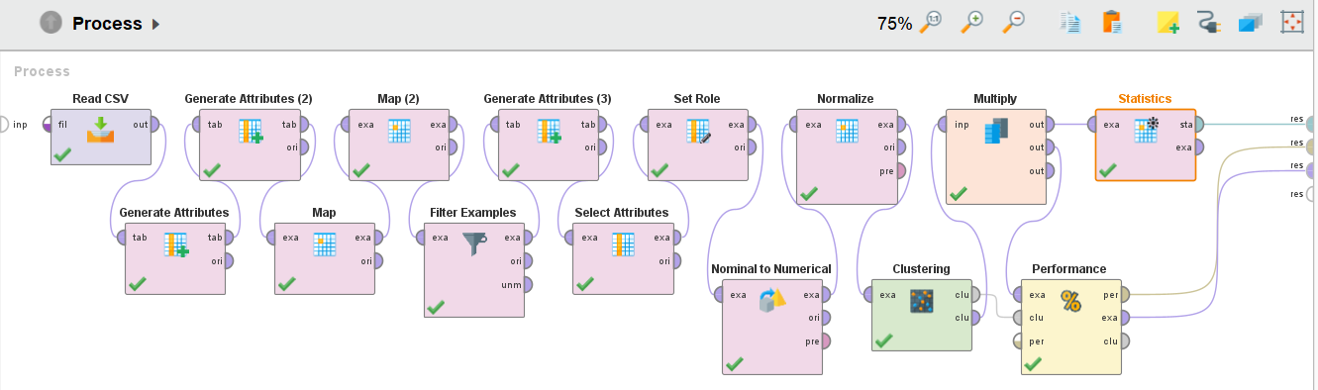
Figure 15: Process Diagram of Q4
Modeling
K-Means clustering. Optimal number of clusters determined by cluster size and Davies Bouldin index.
Optimal Number of Clusters
k | Cluster Sizes | Davies Bouldin | Decision
3 | 424, 33, 1,182 | -1.571 | Selected
4 | 267, 915, 447, 10 | -1.924 | Rejected (tiny 10-item cluster)
5 | 311, 242, 631, 422, 33 | -1.662 | Rejected (unbalanced)
Performance metrics for k=3:
- Avg. within centroid distance: -11.897
- Davies Bouldin Index: -1.571
Cluster Profiles (k=3)
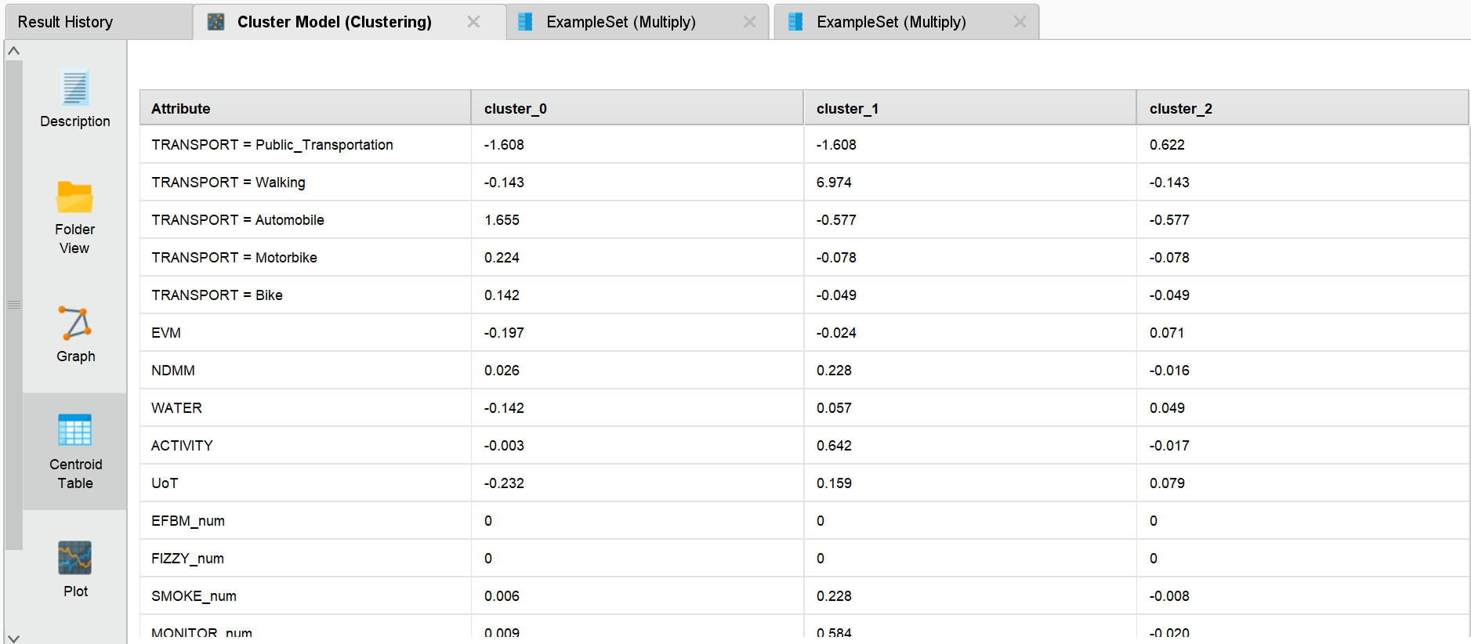
Figure 16: Centroid Table (Z-Score normalized values)
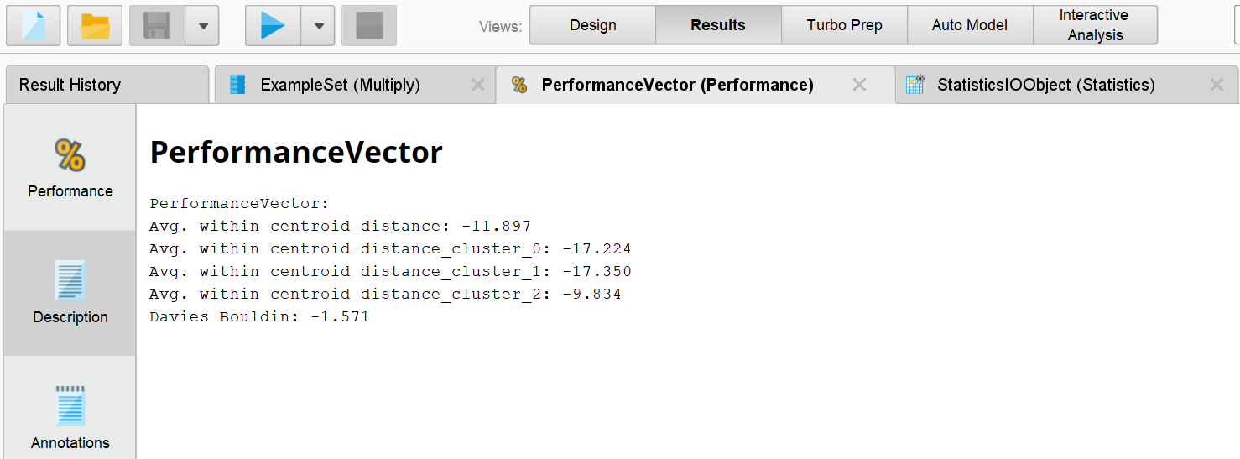
Figure 17: Performance vector
Summary Table – Three Lifestyle Clusters
Cluster | Name | Size | % | Transport | Activity | Diet | Health Status | Recommendation
0 | Car-Dependent Moderate | 424 | 25.9% | Automobile | Average | Below avg veg, water | At Risk | Promote active transport (walking/biking), increase vegetable and water intake
1 | Active Healthy Walkers | 33 | 2.0% | Walking | High | Low junk food, monitors calories | Healthiest | Preserve and study this group identify what enables their healthy habits
2 | Public Transport Average | 1,182 | 72.1% | Public Transport | Average | Average | Baseline | Targeted interventions to increase physical activity and reduce junk food
Key Insights from Clustering
Insight | Explanation
Only 2% are truly healthy | Cluster 1 represents just 33 out of 1,639 adults
Walking is a differentiator | The healthiest cluster defined by extremely high walking scores
Majority are average | 72% fall into baseline cluster with room for improvement
Car dependence = risk | Cluster 0 shows below-average healthy behaviors
Healthy behaviors cluster together | High activity + low junk food + calorie monitoring + walking appear together
Conclusion for Question 4
K-Means clustering with k=3 successfully identified three distinct lifestyle groups. The majority of the population (72%) falls into an "average" category with significant room for improvement. Only 2% exhibit a truly healthy lifestyle characterized by walking, high physical activity, calorie monitoring, and low junk food consumption. Car dependence is associated with less healthy behaviors. Public health interventions should focus on promoting active transportation and reducing car dependency.

Conclusion
Summary of Findings
Question | Key Finding
Q1: BMI Factors | Eating between meals, overweight history, and transport choices most influence BMI
Q2: Obesity Factors | EFBM is the strongest predictor; HoV, gender, and calorie monitoring also critical
Q3: Six Profiles | Activity decreases, male % increases as obesity rises
Q4: Lifestyle Clusters | Only 2% exhibit truly healthy lifestyle patterns
Recommendations
Recommendation | Target | Expected Impact
Reduce eating between meals | All individuals | Lower BMI
Increase physical activity | Clusters 0 and 2 | Move to healthier clusters
Reduce fizzy drink consumption | All individuals | Lower obesity risk
Promote calorie monitoring | Clusters 0 and 2 | Better weight management
Encourage walking/biking | Automobile users | Lower BMI, healthier lifestyle
Limitations
Limitation | Impact
Self-reported data | Potential bias
Young adult skew | May not generalize to older populations
Small sample for some BMI categories | Obesity I had only 294 cases
No longitudinal data | Cannot infer causation
Lessons Learned
- Data preparation is critical, Ordinal variables must be properly converted
- Class imbalance affects model performance, Obesity I had only 2% recall
- Clustering without BMI reveals true lifestyle patterns, only 2% are truly healthy
- CRISP-DM framework ensures structured analysis
- Altair AI Studio effectively handles end-to-end data mining

References
- Altair AI Studio Documentation (2026) https://altair.com/altair-ai-studio
- CRISP-DM Framework Guide https://www.ibm.com/docs/it/SS3RA7_18.3.0/pdf/ModelerCRISPDM.pdf
- WHO Obesity Classification Standards https://www.who.int/news-room/fact-sheets/detail/obesity-and-overweight

